
Lesson 9: On the Scoreboard
GameMaker
VIDEO GAME CREATION
This week: track a real score, and show it - along with your lives - on screen, all the time, not just at the end.
Open your own [YourName]Game project from Lesson 8 - don't start a new one.
Tip: no new assets this week - this is a logic and UI lesson.

Setup
- Open your [YourName]Game project from Lesson 8.

Level 1 - Minimal (MVP)
Destroying an enemy adds 10 points to your score. Score and lives are both visible on screen, all the time, not just at the start or end of the game.
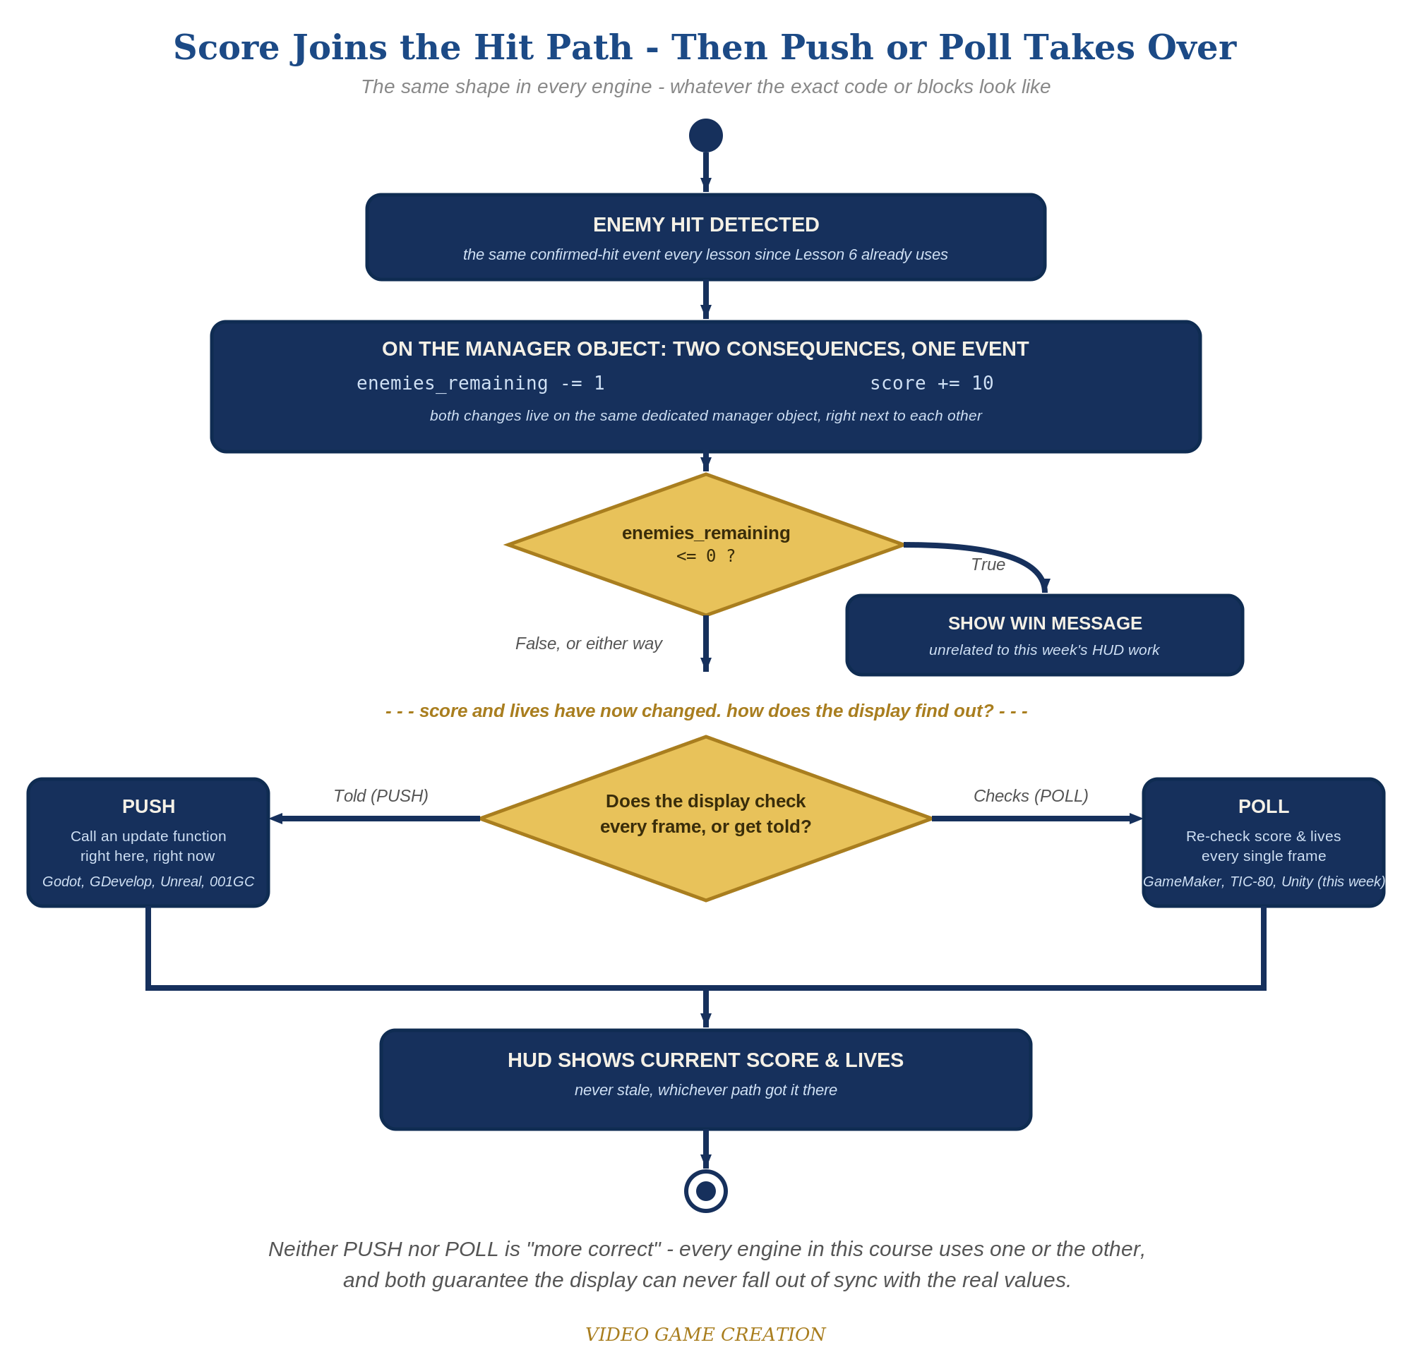
Score joins the hit path, then Push or Poll takes over - the same shape in every engine, whatever the exact code or blocks look like.
- On obj_gamemanager's Create event, add __dnd_score = 0; alongside your existing enemies_remaining/has_won/__dnd_lives/has_lost. (__dnd_score is the instance variable GameMaker's own drag-and-drop Score blocks use - the "dnd" stands for drag-and-drop. Use it instead of the old built-in score, which is deprecated, just as Lesson 8 did for lives.)
- On obj_bullet's Collision event with obj_enemy, add obj_gamemanager.__dnd_score += 10; alongside the existing enemies_remaining decrement.
- On obj_gamemanager's existing Draw GUI event, add two unconditional draw_text() calls near the top, before the has_won/has_lost checks - one for score, one for lives - so they display every single frame, not just at a win/lose moment (code below).
- Press F5 (Run), shoot a few enemies, and let one escape - both numbers should update immediately every time.
Highlighted lines are new this week; everything else is code you already have.
// obj_gamemanager's Create event:
enemies_remaining = 5;
has_won = false;
__dnd_lives = 3;
has_lost = false;
__dnd_score = 0;
// obj_bullet's Collision event with obj_enemy:
audio_play_sound(sfx_hit, 1, false);
obj_gamemanager.enemies_remaining -= 1;
obj_gamemanager.__dnd_score += 10;
if (obj_gamemanager.enemies_remaining <= 0) {
obj_gamemanager.has_won = true;
}
instance_destroy(other);
instance_destroy(self);
// obj_gamemanager's Draw GUI event:
draw_text(20, 20, "Score: " + string(__dnd_score));
draw_text(20, 50, "Lives: " + string(__dnd_lives));
if (has_won) {
draw_text(400, 50, "You Win!");
}
if (has_lost) {
draw_text(400, 90, "Game Over");
}

Alternate Path: GML Visual (no typing)
The same continuous-HUD pattern works with drag-and-drop blocks instead of typed code. GameMaker's Score and Lives blocks are purpose-built: they keep the instance variables __dnd_score and __dnd_lives (not globals), so each block that changes or checks them needs its Target set to obj_gamemanager. The code path uses those same two variables, so the paths are interchangeable.
- On obj_gamemanager's Create event, add a "Set Score" block (Instance Variables category) with Value 0 and Relative unchecked, alongside the "Set Lives" block from Lesson 8.
- On obj_bullet's Collision event with obj_enemy, add a "Set Score" block: click the Target drop-down arrow (upper right of the block), choose obj_gamemanager, check Relative, and set Value to 10. Keep it alongside the existing enemies_remaining block, which stays as a Set Variable block since enemies_remaining is a custom variable with no dedicated block.
- On obj_gamemanager's existing Draw GUI event, near the top before the has_won/has_lost checks, add a "Draw Instance Score" block (Drawing category) with Caption "Score: ", X 20, Y 20, and a "Draw Instance Lives" block with Caption "Lives: ", Sprite spr_player, Stack Order Row, X 20, Y 50 - it draws one small ship per life remaining instead of a number. (Prefer a number? A "Draw Value" block with Caption "Lives: " and Value __dnd_lives does that.)
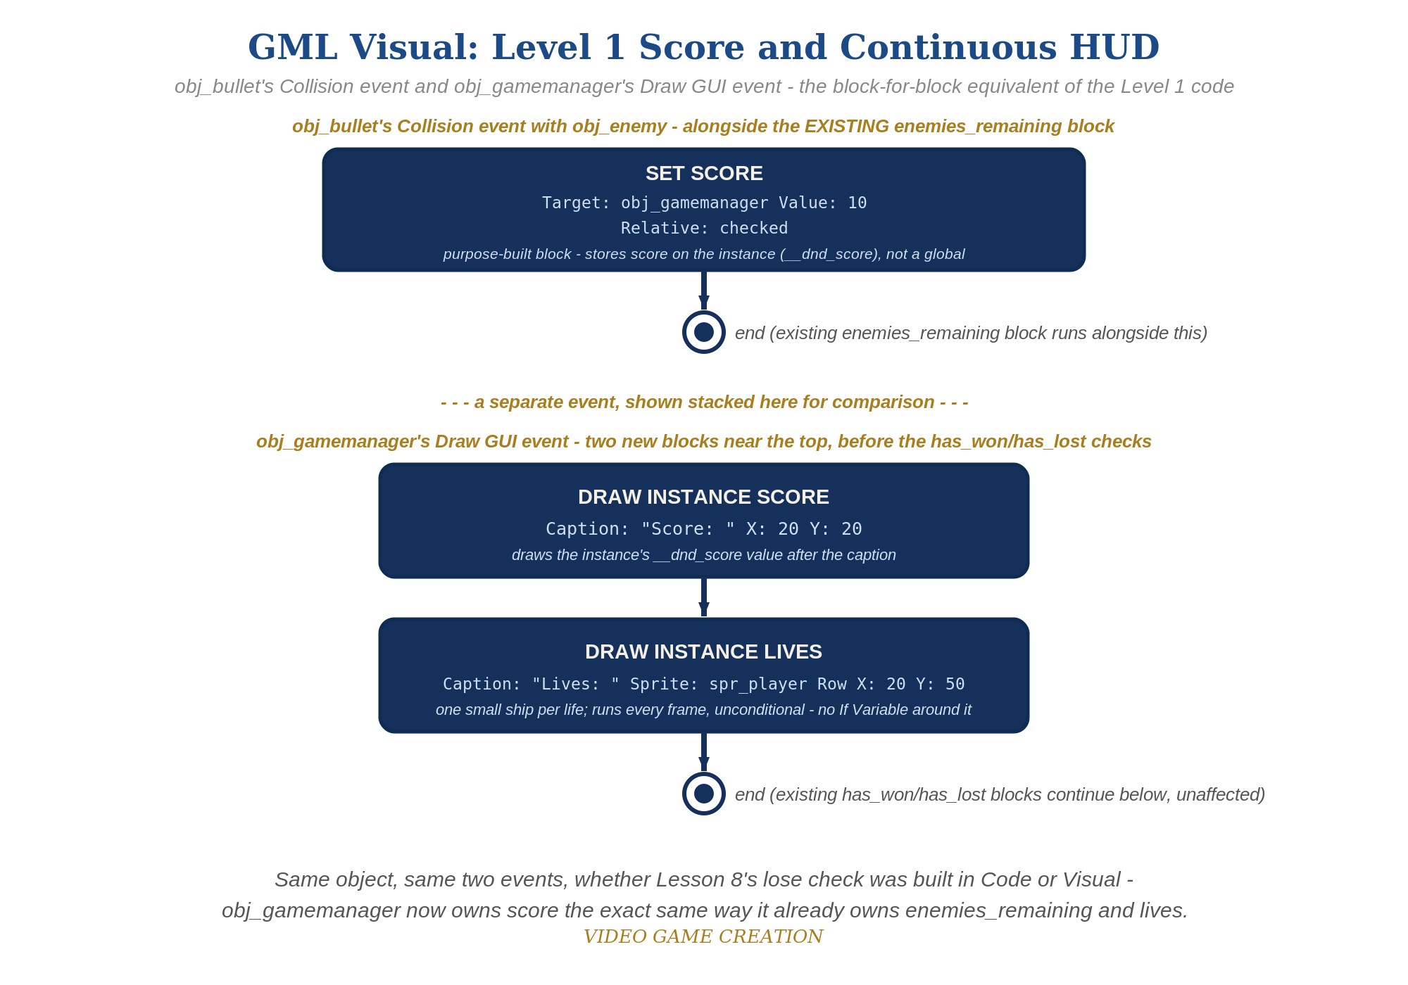
obj_bullet's Collision event and obj_gamemanager's Draw GUI event - the block-for-block equivalent of the Level 1 code.

Level 2 - Complete (Alpha/Beta)
The score and lives readouts never show a stale or wrong number - they always match reality, immediately.
- Shoot 3 enemies and confirm the display reads exactly "Score: 30".
- Let an enemy escape and confirm the score display does NOT change - only the lives display should move.
- Because Draw GUI runs every single frame and reads __dnd_score/__dnd_lives directly (no separate copy stored anywhere), the display can never be out of sync with the real values.

Level 3 - Refined (Ready to Publish) - pick any that interest you
- Visual: use draw_set_font() and draw_set_color() before the draw_text() calls to style the HUD text.
- Visual: change points-per-kill to irandom_range(5, 15) for scoring variety.
- Structure: the score increment lives in obj_bullet's Collision event - the same place enemies_remaining already changes, since both are direct consequences of the exact same confirmed hit.

If Something's Wrong
- Score doesn't appear on screen: confirm the new draw_text() calls were added to Draw GUI, not the regular Draw event (Draw GUI is unaffected by camera/room position, which is why it's used for HUD elements).
- Score changes when an enemy escapes: confirm the score increment is only in obj_bullet's Collision event, not accidentally added to obj_enemy's Step event too.
- Score and lives text overlap other text: adjust the Y coordinates in the draw_text() calls so they don't collide with the has_won/has_lost messages.
- Visual path: Set Score needs its Target (drop-down arrow, upper right of the block) set to obj_gamemanager - left on the default it adds points to the bullet, which is about to be destroyed, and the score stays at 0.

Want More?
Student Resource List > GameMaker section, or gamemaker.io/en/tutorials

